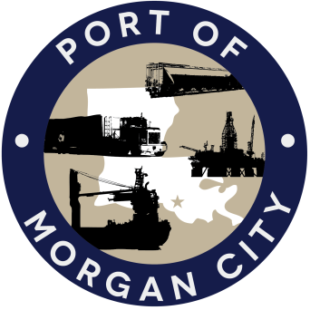

AGENDA

MORGAN CITY HARBOR AND TERMINAL DISTRICT
Regular Meeting of March 13, 2017 – 5:00 p.m. – 7327 Highway 182

- Call to Order

- Roll Call

- Invocation

- Pledge of Allegiance

- Minutes

A. Regular Meeting of February 13, 2017

B. Atchafalaya River, Bayous Boeuf, Black and Chene Stakeholders Workshop of March 3, 2017

- Finance Report
A. Presentation and discussion of financial reports for February 2017 – Deborah Garber
B. Invoices

Guest(s)/Public Comment
A. United States Coast Guard
B. Corps of Engineers, New Orleans District

Raymond “Mac” Wade - Executive Director’s Report

A. Consultant – Michael Knobloch, Knobloch Professional Services, LLC
B. Consultant – Clay Breaud, Providence/GSE
C. Consultant – Michael Lowe, GIS Engineering, LLC
C. Cindy Cutrera, Manager of Economic Development

- Gerard Bourgeois - Legal Report

- New Business

- Old Business
A. Discussion and any action on leasing, improvements, maintenance and repairs to facility(ies), including Coast Guard lease(s)
B. Discussion and any action regarding the U.S. Department of Homeland Security grant program, including request for proposals, bids, purchases, project management, generators, computer data system and NOAA ports system(s)
C. Discussion and any action on Government Operations and Emergency Center including bids, purchases, payments, leasing and Facility Planning and Control
D. Discussion and any action on Atchafalaya River Channel dredging and sediment management, including equipment purchases, reports, survey services, consulting services and economic study(ies)
E. Discussion and any action on 2016 flood fight

- Adjournment

In accordance with the Americans with Disabilities Act, if you need special assistance, please contact Tori Henry at 985-384-0850, describing the assistance that is necessary.

